Standards – open/download PDF files

CHROME
- Type URL CHROME://PLUGINS
- Turn off the Chrome PDF Viewer
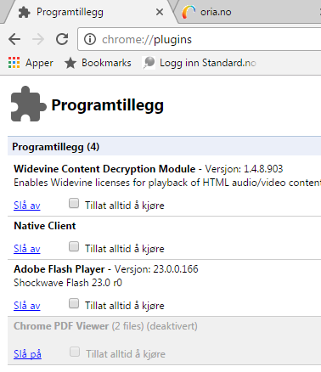
- Connect to the standard.no page (always access this via NTNU UB’s webpage to use the right link)
- Choose the actual PDF - file
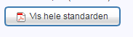
- The downloading page appears
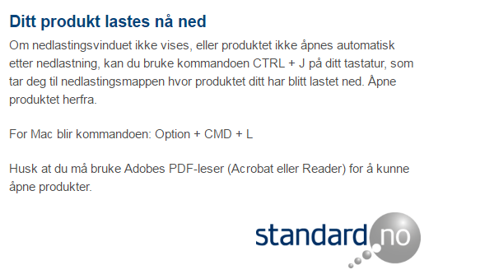
- Can take some time

- The first time you do this a downloading arrow appears in the lower left part of the screen
- Click on the small arrow to the right of the pdf filename and choose “Always open with Adobe Reader»

- The standard opens

- Next time it will automatically open in Adobe Reader

- You can also use in the upper right corner of the screen and choose «Settings» and «Extensions» and activate Adobe Acrobat

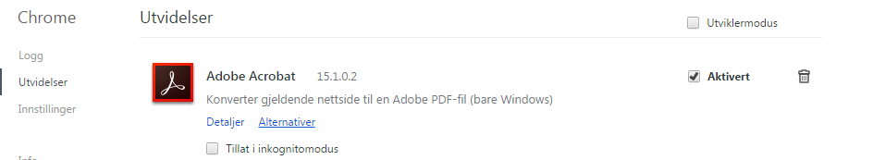

Firefox

- On the toolbar choose «Tools» and «Add-ons» and «Always Activate» Adobe Acrobat

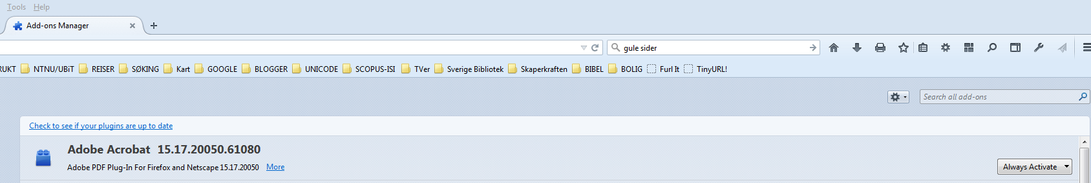

- Connect to the standard.no page (always access this via NTNU UB’s webpage to use the right link)
- Choose the actual PDF - file
- The downloading page appears
- This can take some time
- The standard opens in Adobe Acrobat

Internet Explorer - IE

- Connect to the standard.no page (always access this via NTNU UB’s webpage to use the right link)
- Choose the actual PDF file
- The downloading page opens

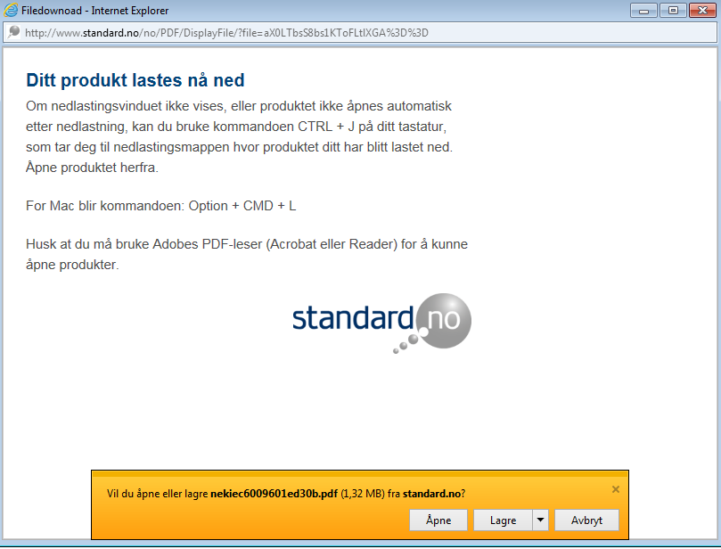

- Choose «Åpne/Open» or «Lagre/Save» depending on your intension

- Adobe Acrobat is the default PDF reader for IE

EDGE (Win 10)

- There are some problems in using EDGE directly
- With EDGE open (not with the configured openingpage) choose the … window in the upper right corner
- Choose “Open in Internet Explorer”
- And use IE as described abowe

RS
NTNU-UB
30.09.16

