Description on how to send packages
Contents
1. Regular packages 1
2. Packages containing dry-ice 2

1. Regular packages
NTNU has an agreement with Norsk Bibliotektransport. Follow this link and instruction: https://i.ntnu.no/wiki/-/wiki/Norsk/Post
For packages abroad it is important to create a pro forma invoice, 3 copies.
When the paperwork is done, you can place your package on the table in the corridor outside the postboxes and caretakers’ offices. E1-021 in Realfagbygget. Daily deadline is 09:00
Alternatively, you may ask for pick up by contacting e-vaktmester (demand notice on picture below). Create a new demand and ask for Transport/ Post. The NV Faculty will cover the cost when using NBT.

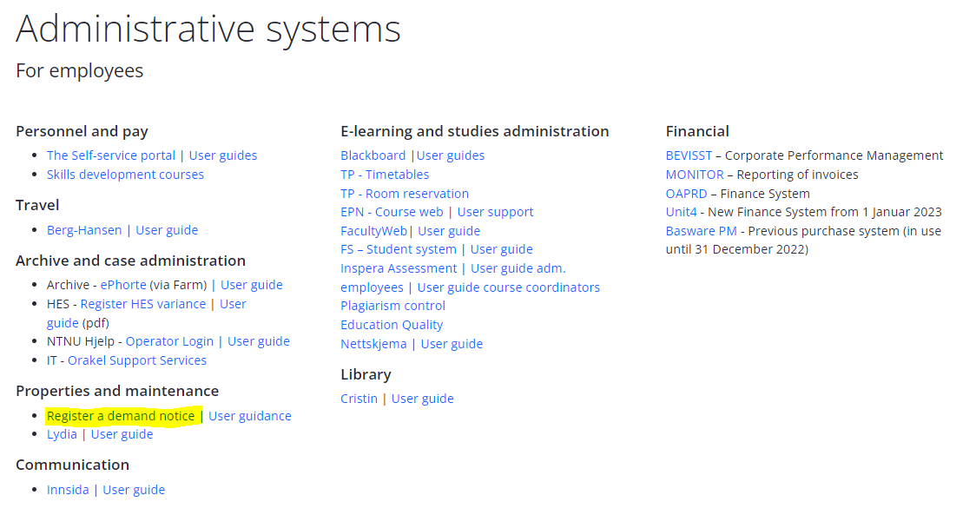

2. Packages containing dry-ice
Packages containing dy ice must be sent by DHL. If you are sending packages on dry-ice use DHL, see procedure below.

Procedure for sending packages with DHL
Sender and receiver
First you should login into MyDHL+.
If you do not have any account, call DHL at 21 00 22 00 or send e-mail to info@kundeservicedhl.no.

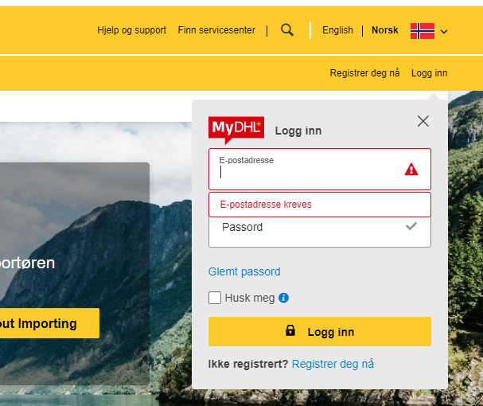
Click ship and create shipment.

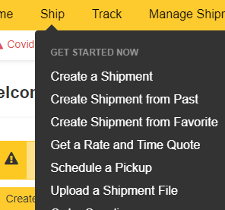

It is also possible to make new shipment from a previous, clicking “Create Shipment from Past”. Another option is to choose create shipment flag here:

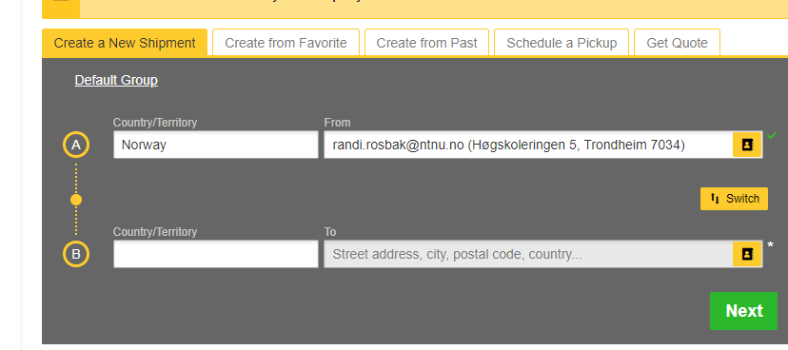

It is possible to find previous address with clicking on this icon. This is an address book.
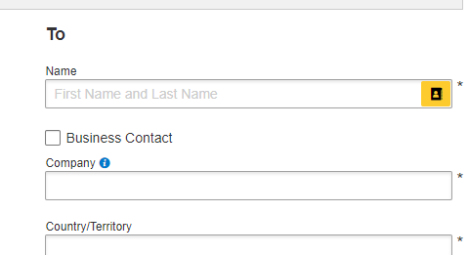
If creating a new address, it is possible to save this to address book.

Save for later
At every step it is possible to save for later.
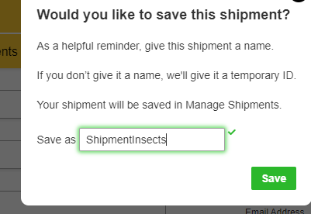
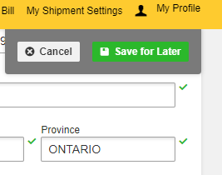
This will be saved under Manages Shipment.
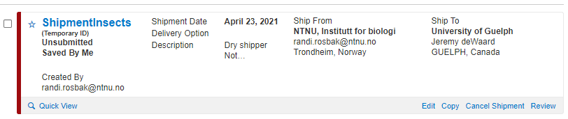
Shipment details
Filling in data for shipment.
Type of shipment and invoices 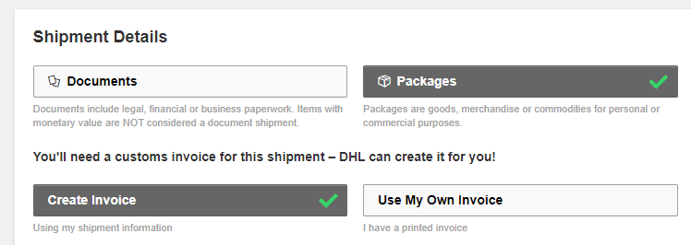

Invoice summary. Click edit.
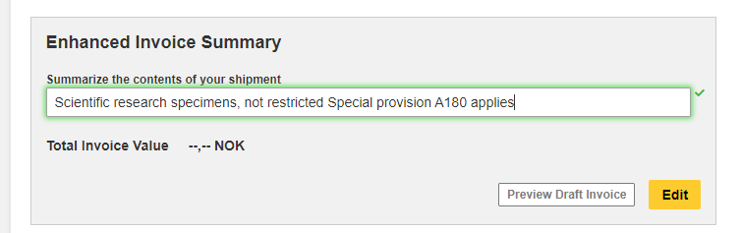
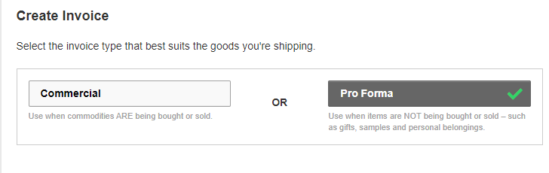
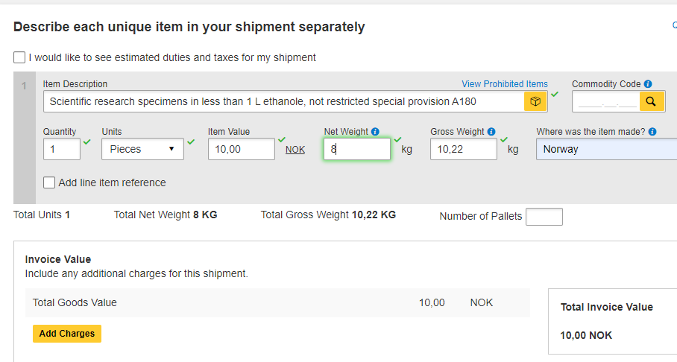
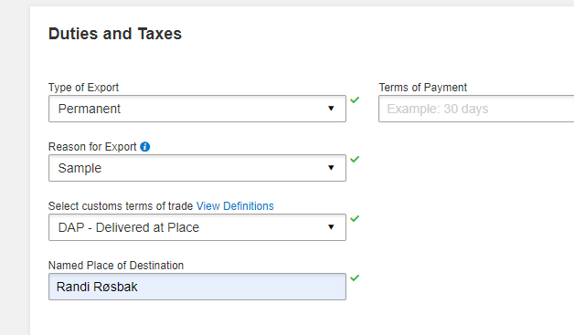
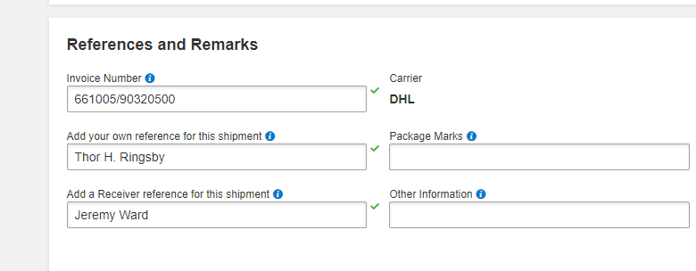
Click complete invoice.
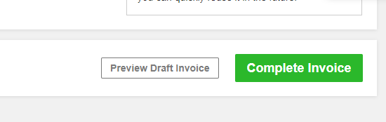

2. References, sending and payment
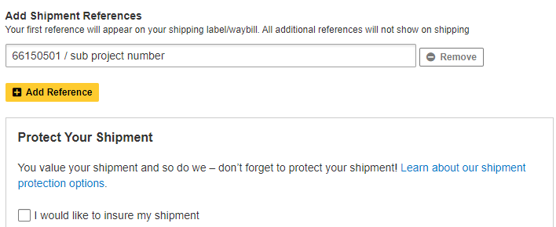
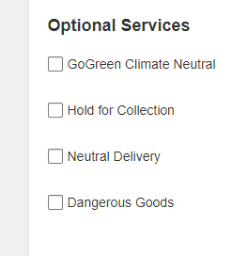
If there are for example dangerous goods, click option needed.

Codes for dangerous goods:
Dry ice UN 1845 and weight in kg

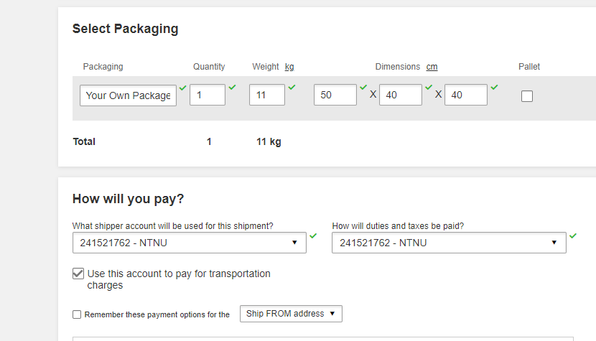

3. Sending and pickup
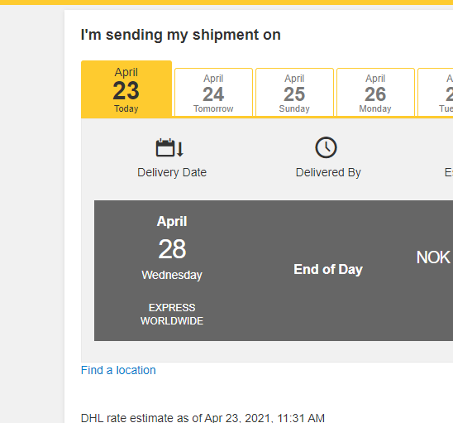

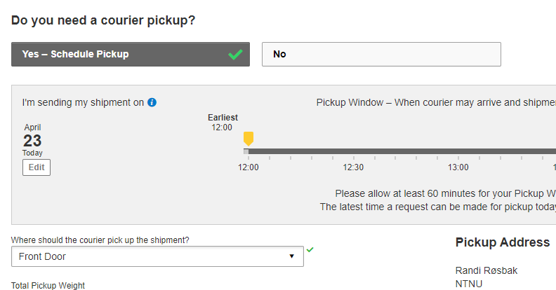
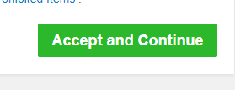
While accepting and continue, pdf files for sending, receipt and pro forma invoice will be made. Remember when clicking this option, shipping is finished, and it is not possible to change settings/data filled in.

Print the documents, and attach to your package.

Tracking number (waybill number) will be created and shipment will be saved in: 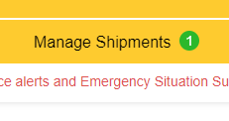
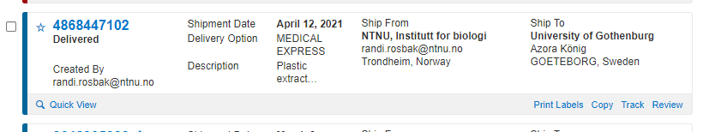

Print labels
When shipment completed, documents can be printed out and shared with others. Documents for foreign shipping are these: 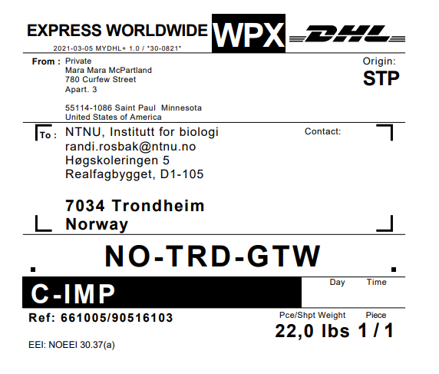
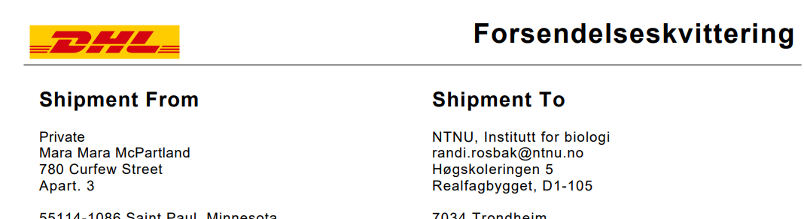

It is suggested to attach sample declaration as well, for easier handling in customs.
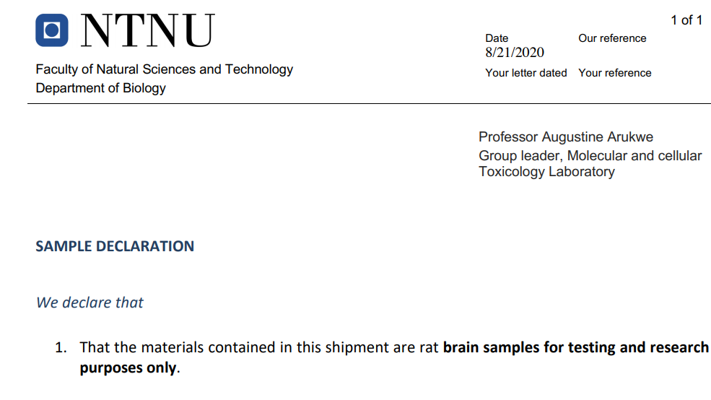

Different codes and account numbers
A-codes and UN-codes
There are several codes for IATA special provision, the most usual at IBI is:
A152 shipping dry shipper with absorbed liquid nitrogen, ex. Not restricted Special Provision A152
A180 shipping samples in ethanol, UN-1170, ex. Scientific Research Specimens, Not restricted Special Provision A180 applies
A197 shipping environmental toxic chemicals, ex. Not Restricted Special Provision A197
NTNU account numbers for IBI
For payment account number, must be filled in. At IBI this is:
241521762 for export
957965210 for import
References
Here K-sted and project number is written, ex. 661005/90320500

Dangerous goods
Regulations from International Air Transport Association (IATA)
IATA Dangerous Goods Regulations 2013 (54th edition)
http://imentaraddod.com/wp-content/uploads/2017/07/533-Dangerous-Goods-Regulations-2013International-Air-Transport-AssociationCorporate-Author92.pdf (26.4.21)
Contact no.dg@dhl.com for questions.

Documents and information possible to share with others
It is possible to share tracking number, pickup confirmation, shipment details, shipment label, proforma invoice and shipment receipt. This is available when printing out shipment documents. Click share shipment details and fill in requested information, like contact information and shipment description.

Order pickup outside NTNU and return shipment.
It is also possible to order shipment and pickup outside NTNU. Here the sender (from) address is person A shipping items to NTNU, which will be the receiver (to). The costs must be accounted for a NTNU-project number.
Returning items to NTNU is also possible. There are options for filling in this in shipment details, requesting if you want return shipment documents.

