Skjem

Phase 1 – Preparation for the Work Environment Survey 2019

Unit name:
Leader and safety representative names:
Date:

Achieving NTNU's goals requires continuously working to improve the psychosocial and organizational work environment. The Work Environment Survey is an important tool in this work. In preparing for a new survey, it is useful to reflect on experiences from previous work environment efforts at the unit, factors that have influenced the work environment since the last survey, and objectives for further improving the work environment. This conversation guide is intended as an aid when preparing for the general meeting and presentation of the new survey.

The form replaces the previous FaktaARK1, and should be filled in by each leader in collaboration with safety representatives and other relevant key personnel (e.g. leader support/Work Environment Survey coordinator for the faculty/sector).

The form must be completed and filed in ephorte in the unit dossier by 30 October 2019.
NB! A dossier will be created for each unit to present the results of the survey: ‘Work Environment Survey 2019 UNIT ABBREVIATION’. A list of the unit abbreviations used in the survey will be available on the survey web page from October 2019 onwards.

If you have any questions, contact the coordinator of your Faculty/area in the central administration.
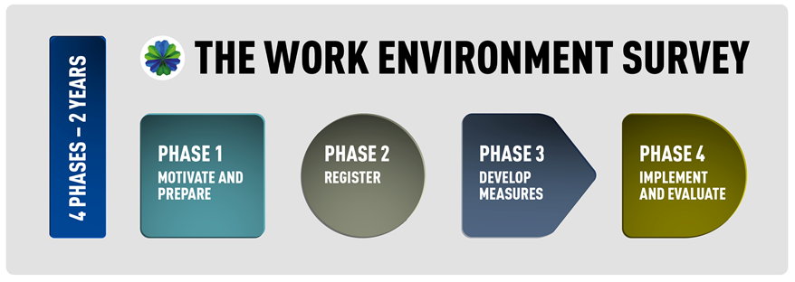

Questions to prepare:

- How can we use past experience in the best possible way? Think about how you have worked during the various phases of the Work Environment Survey.

- Follow-up of action plans from the previous survey:
a. Which measures were effective? Why?
b. Which measures were less effective? Why?

- What factors have affected the working environment since last time (e.g. new management, structural changes, high turnover, conflict)? Names, job titles and other identifying information should be omitted.

- Work environment improvement and measures should support NTNU’s primary activities of research and teaching, and must therefore always be viewed in light of this. How can we use the Work Environment Survey and our efforts to improve the work environment in other ongoing processes?

- What do we want to achieve with the work environment efforts at our unit?

