Ordering procedure at IBT

- Fill in the purchase request form found at this web-site: https://i.ntnu.no/bestille

- Select, Faculty unit: NV-fakultetet
Relevant group /unit: IBT fagbestiller

- Fill in the items you want to order.
- Remember to tick these boxes:

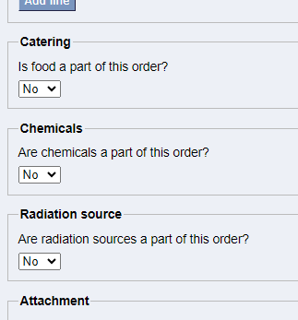

- If “Yes”, fill in as requested.
- Fill in name and telephone number.
- Fill in cost centre (66150501 for IBT) and sub-project number, 9 digits.

NB! For new chemicals, that are not registered in the Chemical index, attach the safety data sheets for the chemicals.

Incomplete forms will be rejected.

