The NTNU Postdoc Action Pilot 2017-2019

Final report

February 2020

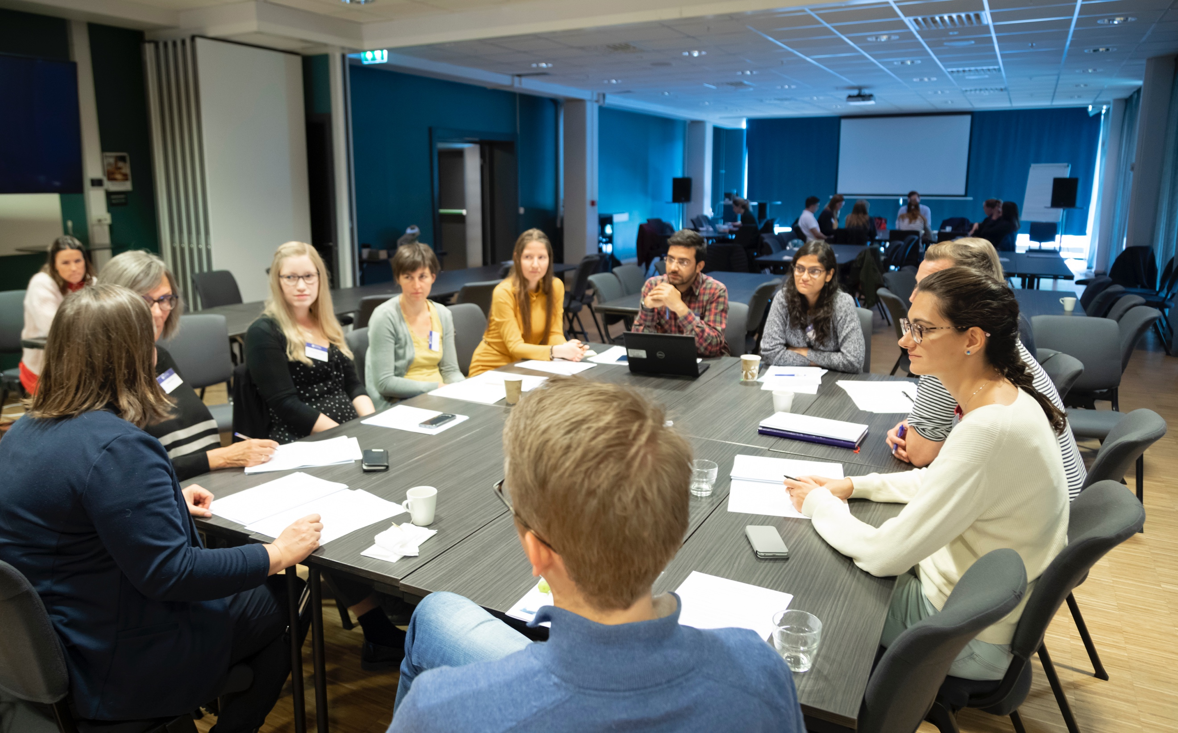
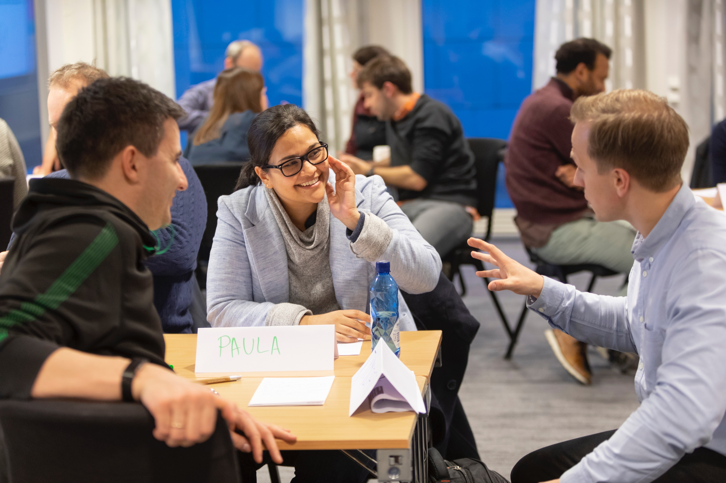

www.ntnu.edu/postdoc
The NTNU Postdoc Action pilot 2017-2019

Final report

February 2020

Introduction

On the recommendation of NTNU’s Research Committee, in March 2017 the Rector decided to launch the “Postdoc Action.” NTNU intends to systematically support this talented group of people, both to help them develop good careers, improve the utilization of this important research resource, and strengthen prospects for recruitment to scientific positions in academia. The Postdoc Action (Norwegian name: Postdoktorløftet) is a strategic commitment developed in cooperation with the faculties.

A two-year pilot program was launched in autumn 2017 with 33 postdocs from all faculties. The participants are offered support in the form of template tools for performance appraisals and career plans, events and courses, a mentor, and the opportunity to apply for financial support for international mobility. The participants provided feedback to the working group (two Vice Deans from the Central Research Committee, two postdocs and the coordinator from the rector’s staff) during the pilot.

The aim of the Postdoc Action pilot has been to create the basis for a postdoctoral policy with supportive initiatives and to develop new NTNU supplementary provisions to the national postdoctoral regulations, which will have an impact for all postdocs at NTNU. The final evaluation is based on the Postdoc Action’s main aims and activities made available to the pilot participants.

This report is mainly on the feedback collected using a questionnaire distributed after the last group event in 2019, at the end of the pilot. In total, 18 postdocs and 22 mentors responded to the final online evaluation in its entirety. The purpose of the final evaluation was to identify how both the pilot as a whole and the different initiatives were perceived and used; to what extent were the offerings valuable and relevant? What have been the greatest challenges in the pilot and what can we learn from them? Where relevant, the report also builds on input collected both during the pilot and through the midway evaluation (autumn 2018).

The report provides an overview of the pilot group’s profile and the variety of events organized during the 2-year pilot period, followed by an evaluation and discussion of the various initiatives in greater depth. The report concludes with a brief discussion and summary of the key factors.

Profile of the group

At the start of the pilot in 2017, 61% of the participants were foreign nationals and just over a third were Norwegian, with ages ranging from 27 to 51 (average age 36). In total, there were 33 postdocs. For three out of four participants, this was their first postdoctoral fellowship. More postdocs were invited to join during the period, bringing the total to 37.

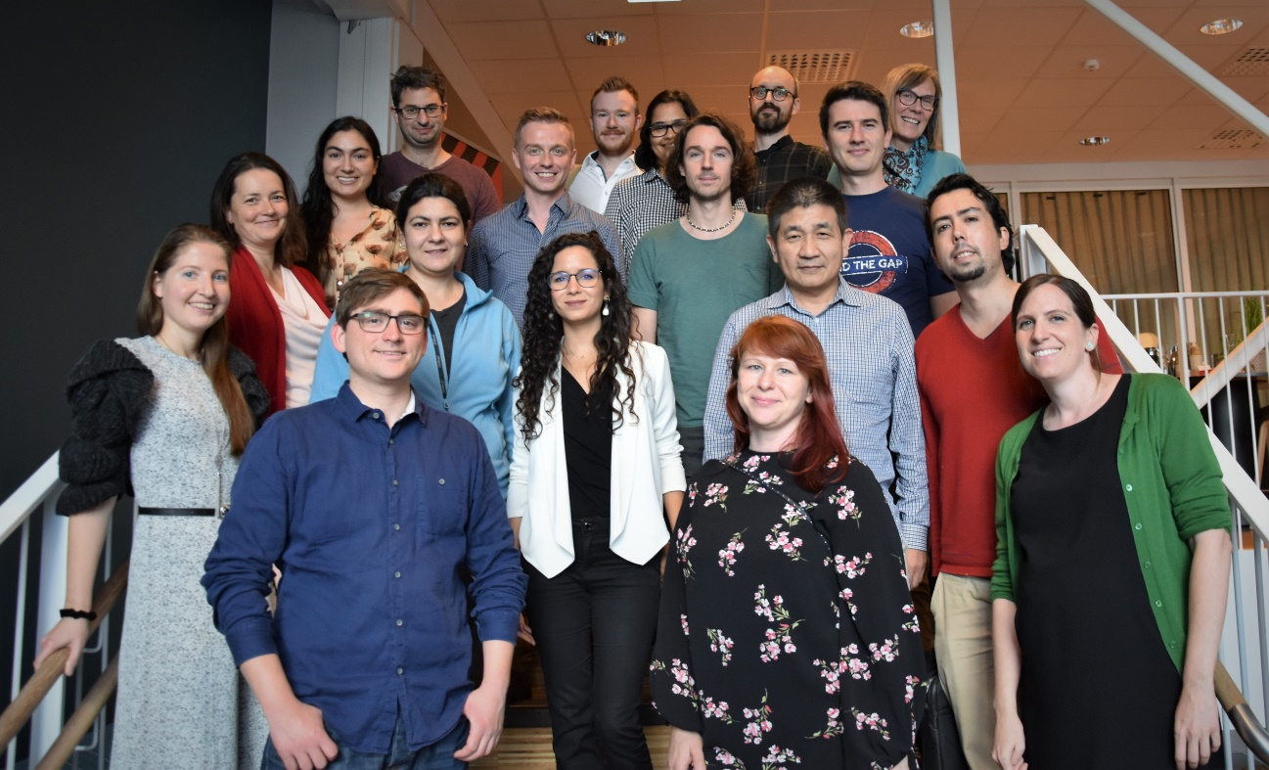
Group photo of postdocs at a group event held on 7 September 2018

Events

The pilot offered a total of ten group sessions and courses – nine in Trondheim and one in Hell. The programmes are attached.

29.11.17 Introductory event with aims of the pilot, meet and greet, networking, information about mentoring, career planning. Mini-course on research communication.
21.03.18 Event involving both postdocs and mentors. More input on mentoring.
23.05.18 Event focused on writing applications.
24.05.18 Course in PhD supervision
07.09.18 Exchange of experience midway through pilot. Course in innovation (TTO)
28-29.11.18 Course in management of research (2 days in Hell, Stjørdal)
28.02.19 Seminar in team-based learning, including course certificate.
26.06.19 Kayaking organized by a participant and supported by the Postdoc Action
30.08.19 Career conference. Content: Presentation by six PhD alumni from NTNU who now have careers outside academia. Group activities, networking.
12.12.19 Final seminar, for both mentors and postdocs. Content: Exchange of experience in mentoring from both perspectives, mobility and job search outside the university.

The diagram below indicates which aspects of the Postdoc Action the participants found most valuable, according to the final evaluation. The results will be discussed in the next sections of the report.

Participation

Of the 37 postdocs in total who were invited during the pilot period, at least 12 withdrew before the end of the pilot, mainly due to changes in their work situation. As the summary on page 2 shows, the pilot included ten events including courses and social activities. The average participation rate in the events was high (50-85%) during the first 6 months of the pilot, and it was especially high at the introductory event. After the first half-year, the participation rate declined and remained at 50% or lower. Postdocs outside the pilot were therefore invited in order to increase participation (to about 35 people) in the various events. One explanation for the variation in participation might be that postdocs are busy, while another might be that not all topics were equally attractive to everyone.

Mentoring

Before the Postdoc Action programme, 30% of the 33 initial participants had a mentor. Through the programme, all participants in the pilot were assigned a mentor from NTNU. Of these, 60% did not know their mentor before the pilot, and in 75% of cases the department or supervisor helped match the postdoc with a mentor. The mentors were employed at the same department (43%), at another department in the same faculty (33%), or at another faculty (23%).

Two out of three mentors said their relationship with the postdoc had been good, slightly fewer than at the midway evaluation (about 80%). Almost half of the mentors replied that the postdoc had taken the initiative to meet them. While 60% of postdocs answered that mentoring had been a valuable aspect of the pilot, only a third wanted to continue the mentoring relationship after the end of the postdoc period. Fully 89% of the postdocs and 77% of the mentors felt that it should be mandatory for postdocs at NTNU to have a mentor, but the vast majority of these made it clear that there would need to be an opportunity to opt out. Asked whether mentors should receive compensation, more than half answered “no,” but the response from others was a strong “yes.” Relevant compensation might involve counting mentoring as hours or teaching, or creating a fellowship position. One mentor wrote: The future of such a programme depends on this, while another wrote: the involvement is rewarding enough and crediting enough in itself. During the pilot, several mentors and participants mentioned that they would like more group events. This was fulfilled once during the first year and a second time during the final seminar, where both a mentor and a postdoc had an opportunity to present their experience with the pilot. The mentors responded that they spent an average of 8.9 hours per year on mentoring.

Short versions of statements from postdocs and mentors:

+ Mentoring | - Mentoring
“My mentor is a very successful scientist and it is very motivating to discuss my career with him. He gave me a lot of advice on what is important if I want to succeed in academia.”  “It should be strongly valued as teaching.”  “Positive was that she gave me a realistic perspective and also, she motivated me through positive reinforcement of my achievement. She was good at acknowledging the small steps and seeing them in a larger career plan. She gave me the confidence to take on a guest research stay abroad with my family. Not so much negative, but I wish she could have helped me more strategically with my career plan.”  “I think the platform for postdocs to meet and discuss is a very good idea. I also appreciated having a mentor.”  “I think postdocs could also serve as temporary ‘mentors’ or sparring partners to each other - at least at the meetings and provide feedback to each other”  “It has been a positive learning experience. Also, as a mentor approaching retirement it has been a valuable chance to share experience within and with academia”  “I have clearly seen the need for an informal contact to answer all the possible questions a postdoc might have” | “He was located in [a different town], we hardly have had any time to meet”  “I chose my mentor myself and might in hindsight have better chosen somebody else (or might have been appointed to somebody else).”  “My mentor never appeared at the program meetings. Perhaps NTNU could book a meeting for both of them, then we would meet. It is just this kick-off which is important, then it probably would roll on it own. But I just put low priority to meeting him and so it never happened.”  “it has been positive and I have had no negative/challenging experiences, except that time spent has not been remunerated. If I were to be asked to mentor again on the same terms, I would decline to participate. It is like supervising without shared research interests/projects.”  “The mentoring programme started OK, and with good intentions, but somehow the activity died during the second year. This may be because we were not able to build the necessary good relationship, because we were too different scientifically, or because the work position of the mentee changed during the pilot project.”  “I think I never had a mentor in this program. If there was a mentor assigned to me I have never met with him/her.”

Internationalization

The postdoc group had a relatively varied educational background. Of the original participants, 46% had a PhD from NTNU, 9% from other Norwegian universities, and 46% from outside Norway. Of the Norwegian participants, 23% had previously had a research visit abroad of 3 months or more. This provided a basis for including internationalization as an aim of the Postdoc Action.

The Postdoc Action offered up to NOK 50,000 in funding for researcher mobility, both outgoing and incoming. It was possible to apply for funding for both short and longer visits. In total, nine applications were granted for exchange with the following research institutions, and only one of them included inbound mobility:

- King’s College London, UK
- University of California, Los Angeles, USA
- Lawrence Berkeley National Laboratory in Berkeley, USA
- EAFIT University in Medellín, Colombia
- Università di Bologna, Italy
- École Polytechnique Fédéral de Lausanne, Switzerland
- Polish Academy of Sciences, Poland
- UNICEF headquarters in New York City, USA
- Yale University, USA

Half of the applicants were men, and two out of nine were Norwegian. This means that the action may not have reached many of those who would have benefited most from it. Almost all applications were for amounts between NOK 40,000 and NOK 50,000.

Six of the 18 who responded to the full final evaluation had worked on an application for research funding from Norwegian sources. Five had worked on applications for funding from international sources, including Horizon 2020, Marie Curie and Fulbright. Four had not started working on applications, but are planning to do so, while three have no plans to submit applications.

Short versions of statements from postdocs:

Mobility challenges for postdocs

- “My job is located in Norway with Norwegian data. I have small children.”
- “I wanted to focus on my work here.”
- “I have had 2 guests at NTNU. I did not apply for the mobility grant because I didn’t know about it. My mistake.”
- “Seems too demanding to combine with moving the family (and the amount is too small to move the whole family)”
- “I have two small children, so I did not consider going away for longer than a conference.”

Career planning

Career development has been a key aspect of the Postdoc Action. The career plan is an activity that makes career goals clearer through creating awareness and documentation. The career plan is to be followed up regularly with annual employee development and appraisal interviews.

At the time of the final evaluation, 56% of the participants stated that they had discussed a career plan with their research group leader or other professor, 50% with their mentor, 33% with colleagues at their department, and 22% with the Head of Department. All of these reflect a lower proportion than was reported in the midway evaluation. In contrast, 17% had discussed a plan with other participants in the Postdoc Action, which was up from 5% in the midway evaluation. During the pilot period, 56% had completed or planned an employee appraisal interview. The others had not been offered such an interview during the two-year period. Of the respondents, 40% answered that the pilot was useful for career planning within academia, while only 10% thought it was useful for career planning outside academia, despite the seminar focusing on knowledge-based career paths outside the university with alumni who had a PhD from NTNU.

At the end of the pilot, 39% of the participants had a written career plan, and 22% had used the template provided by the Postdoc Action. This does not show a change from the midway evaluation. There were mixed opinions among the participants on the usefulness and relevance of a written career plan.

Networking
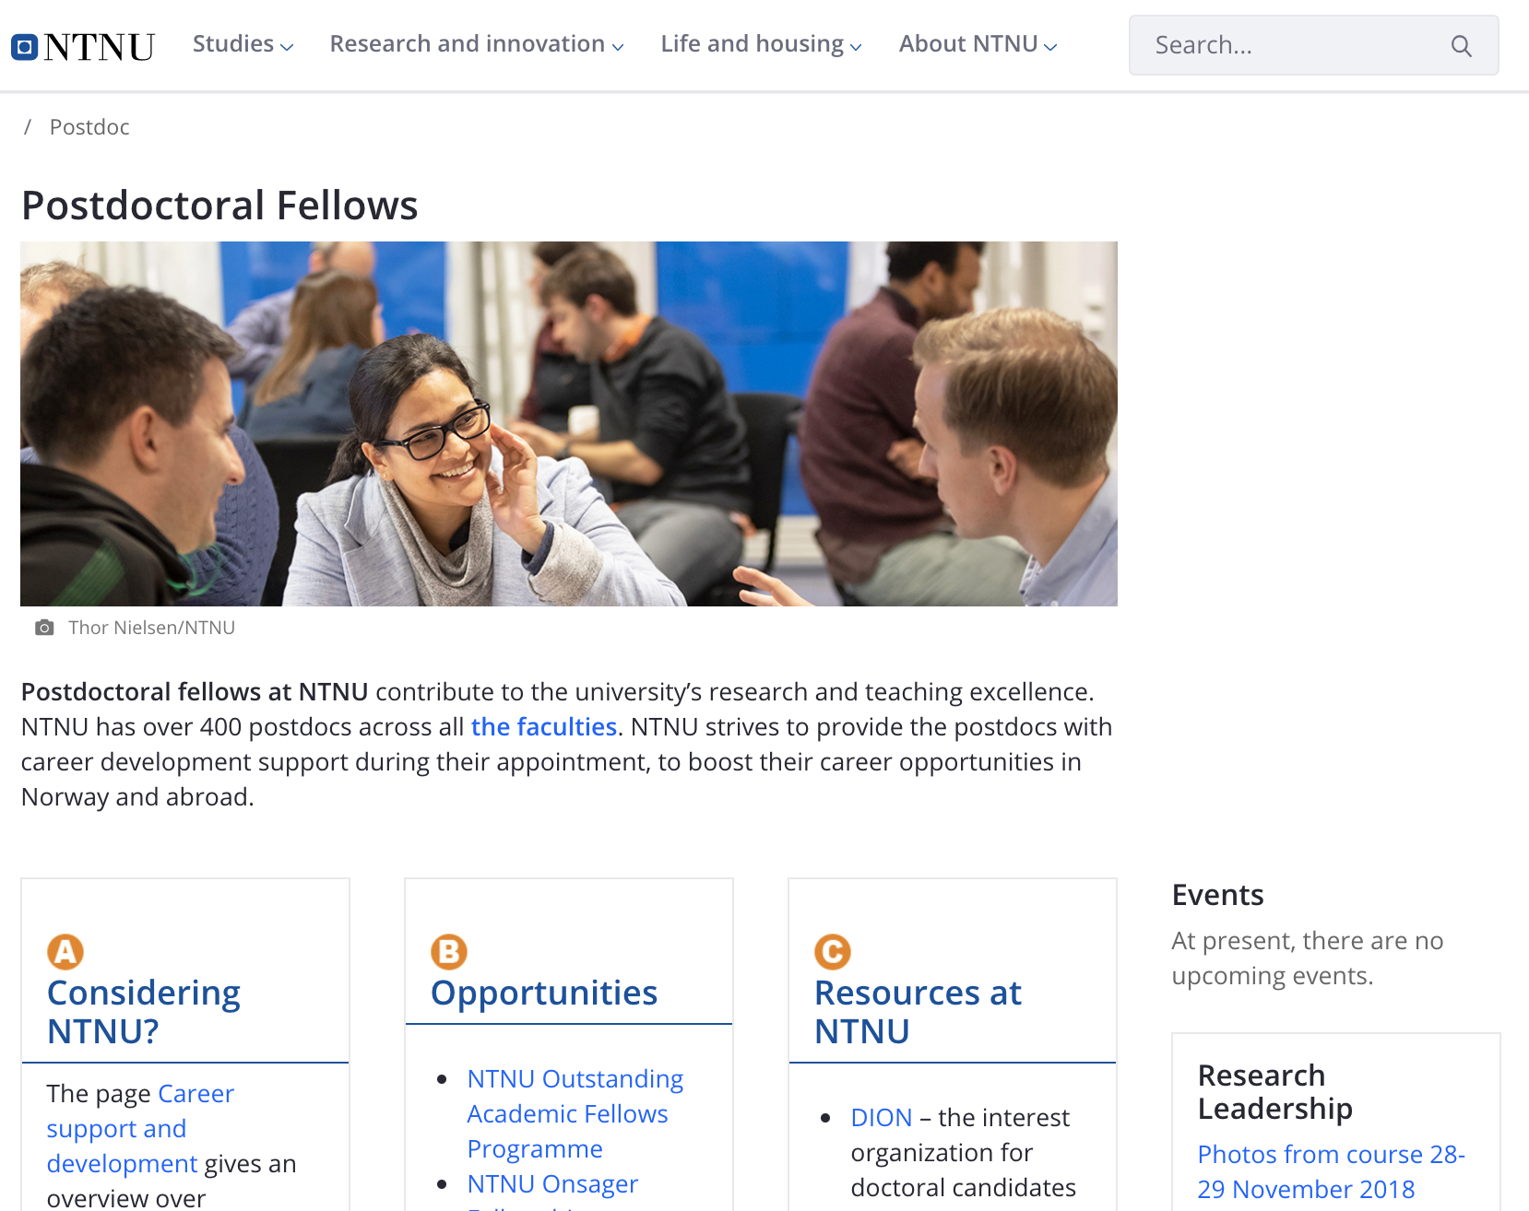
Before the Postdoc Action, postdocs at NTNU had no shared physical or digital meeting place. There was no dedicated Innsida channel, email list, website, or common events for postdocs organized by NTNU.

Through the Postdoc Action and in cooperation with the Communication Division, a portal designed for postdocs was launched (see the screenshot to the right, www.ntnu.edu/postdoc). As of February 2020, the website has had 4544 unique visitors and 435 returning visitors. Two pages with more detailed information were also developed on Innsida:
https://innsida.ntnu.no/wiki/-/wiki/English/The+Postdoc+Action+Pilot+Project
and https://innsida.ntnu.no/wiki/-/wiki/English/Career+support+and+development+for+postdocs

Social activities and networking were considered the next most valuable aspect of the Postdoc Action (50%), after mentoring (60%). The group events worked so well that some of the participants said they would like to arrange informal get-togethers during the periods between the seminars, especially for groups in the same or related disciplines. This was fulfilled with a kayaking trip in the summer of 2019, which was organized by a participant with support from the pilot.
“As a participant, what do you like best about the pilot? (from the final evaluation)

- “the internationalization, because it gave me the opportunity to work with top researchers and institutions in my research domain.”
- “Research mobility support as well as networking.”

Training courses

Half of the participants reported that it had not been easy to make Postdoc Action activities a priority, due to other commitments, but several said they valued being able to participate. Most people responded that participating in short courses (1-2 days) on specific topics was useful for their career development and felt that the courses offered were good. We received particularly good feedback for the research leadership course with Lars Christian Lassen from Mobilize Strategy Consulting and for the course on PhD supervision with Professor Kari Smith. Some elements of the course offerings were less relevant to some participants (for example, patenting), and many responded that the selection of courses was too limited. Others expressed a desire for specialized course offerings within their disciplines. Overall, there was broad consensus that training courses were not only needed, but also useful. However, the preferences for the type of course content reflected the diversity of the postdocs’ disciplines as well as varying expectations about future career paths. Several participants suggested introducing activities that involve networking early in the programme to get to know one another and develop contacts more quickly.
Statements from participants (from the final evaluation):

“The course on leadership was one of the best courses I ever attended to, past my Masters degree.”

“For me more frequent (every month) but shorter events would be easier to schedule in (for example a series of meetings about one issue) but this depends a lot of type of research that particular person is conducting.”

Statement from participant (from the midway evaluation): “The most important thing for the future is that all postdocs at NTNU must have access to the courses we have been offered.”

Discussion

The two evaluations (midway and final) of the Postdoc Action pilot indicate the most impotant elements to take forward when developing an action plan for postdocs starting in 2020. At the same time, the experience from the pilot shows that postdocs are a challenging group to reach with initiatives engaging for every individual. Attendance at the various events and courses decreased among the participants during the pilot period, but at the same time it was easy to attract other postdocs who were not part of the pilot. This indicates that postdocs were interested in the topics presented, but that it was not possible to count on adequate involvement given the limited number of postdocs in the pilot and the group’s heterogeneity. Several of the pilot participants commented that lack of time is the reason that they could give priority to taking part in meetings and courses. Nevertheless, NTNU should organize courses open to postdocs; here, courses in teaching, PhD supervision, and research leadership, should be given priority.

Although 60% responded that mentoring was the most valuable aspect of the pilot, the mentoring scheme did not work equally well for everyone. A first meeting between the mentor and the postdoc at an early stage to clarify expectations and plan their work together might remedy these problems. Several participants had opinions on how the mentor is selected, and an important success factor for the relationship is that both the mentor and the postdoc set aside time for it. In summary, all postdocs should be offered a mentor, but this should be a voluntary scheme for the postdoc, and it must be possible to end the mentoring relationship if it does not provide any added value. The mentors replied that this should not take much time either (on average, the mentors spent about 9 hours a year on mentoring and meeting with their mentees), and over half of the mentors replied that compensation was not necessary.

Several reported that they appreciated social activities and networking. The postdocs would therefore appreciate dedicated opportunities for getting to know other postdocs and exchanging experiences with them across disciplines. An annual career conference to which all postdocs at NTNU are invited could provide an arena to meet this need. The flow of information could be improved, but much of the responsibility must rest with the postdocs themselves. A shared website has been created (www.ntnu.edu/postdoc), launched on 29 November 2018 by the Communication Division. The midway report also proposed a dedicated mailing list and Innsida channel for postdocs, based on good experience from the pilot. Ground rules for the use of this mailing list should be established to ensure that email traffic does not grow to unnecessary volumes. Based on experience from DION’s mailing list, which includes both postdocs and PhD students, the chances of large volumes of email traffic appear to be fairly low. These channels would provide a way to engage in a more continuous dialogue with colleagues. They could also provide a platform for mutual communication and give postdocs the opportunity to take the initiative for informal meetings and sharing career prospects.

Summary

NTNU must provide a better offering to all postdocs at NTNU. Although postdocs are difficult to reach and lead busy lives in their temporary positions, this talented group of employees should be offered attractive opportunities and a variety of initiatives that can help them progress in their careers. An initial dialogue with the development of an individual career plan just after appointment is perhaps the most important initiative of all. It is also important to meet the need for mentoring, regular employee interviews with follow-up of career plans, internationalization, career conferences, a variety of course offerings, and opportunities for networking with other postdocs. The department and the central level of the university should primarily share the responsibility for postdocs at NTNU.

The Working Committee for the Postdoc Action
Vice-Dean Bjørn Myskja (HF) and Vice-Dean Pål Romundstad (MH)
Postdoc Kam Sripada and Associate Professor Katrien De Moor
Coordinator Ragnhild Lofthus (Rector’s Staff - Research)

