Package labeling example: EU standards

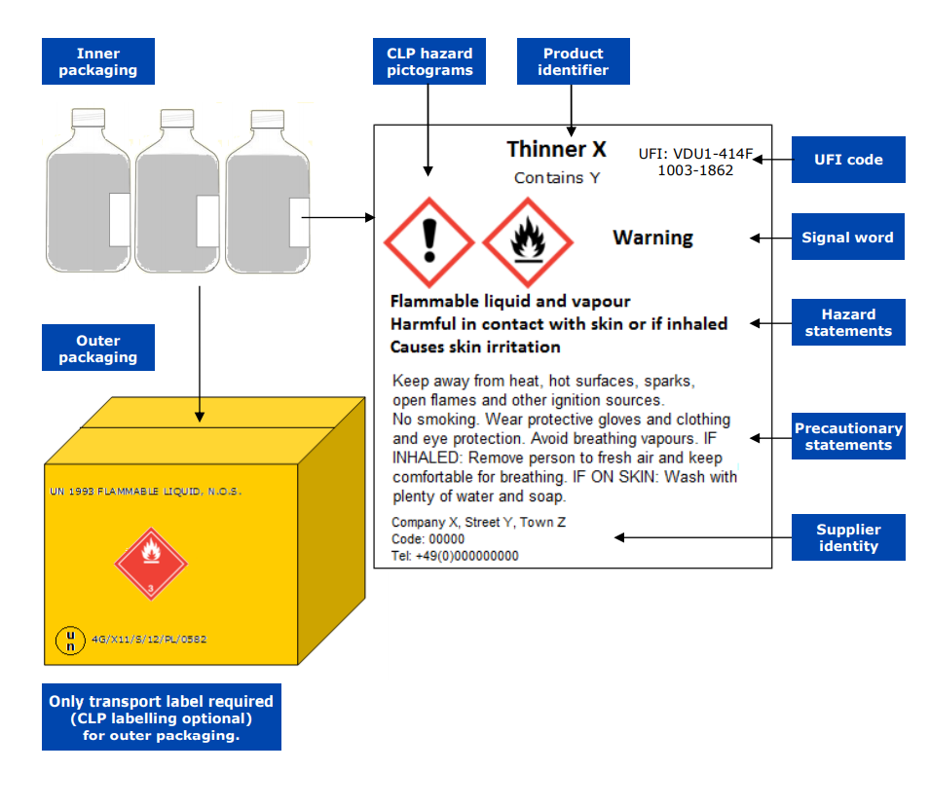
Figure 1
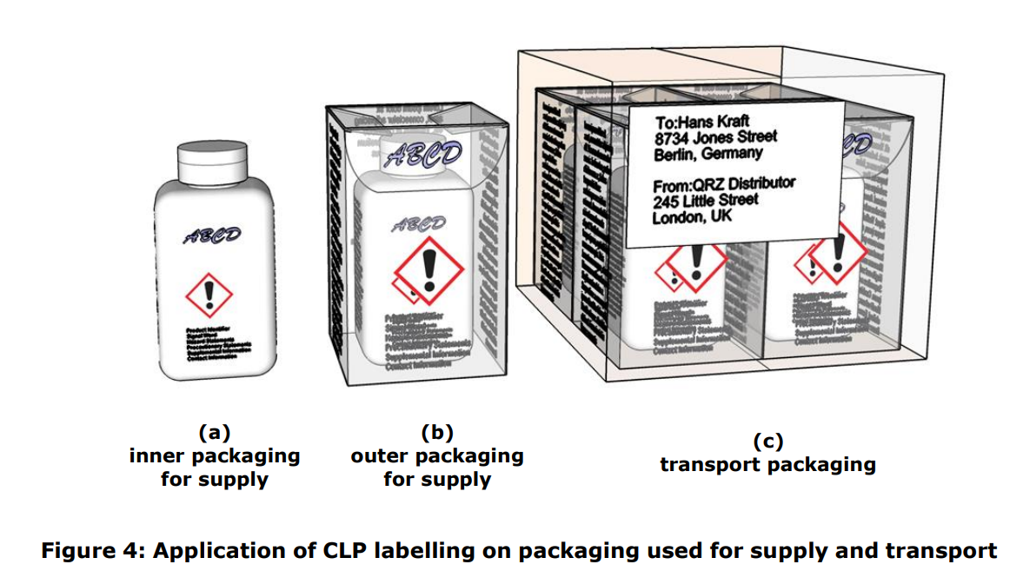
Figure 2
Source: Guidance on labelling and packaging panel - Guidance on CLP - ECHA (europa.eu)

