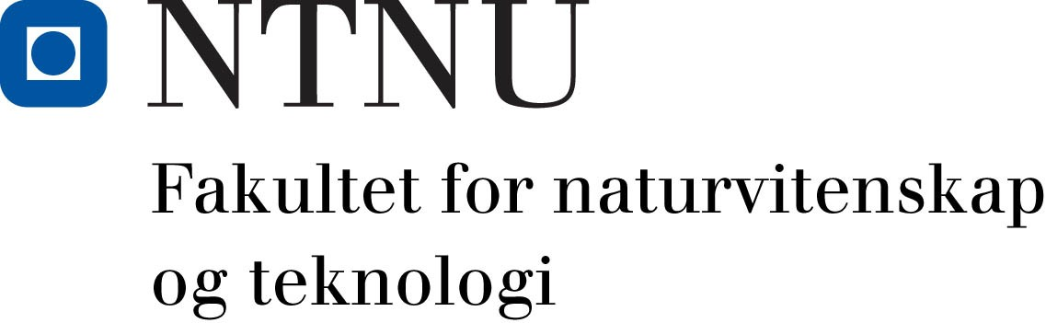

Additional employment contract in connection with change of workplace for employees posted abroad
(For work abroad longer than 1 month, under Section 14.7 of the Working Environment Act [Arbeidsmiljøloven])
Name of employee:
National identity number (11 digits)
Address:
Position title/grade code
Full-time equivalent/salary grade

NTNU, Fill in unit here...

approves a change in the employee’s place of work in connection with:
Reason for change in place of work:
New place of work:
New home address: |  |  | Telephone:
Length of stay, FROM date: | Length of stay, TO date: | Country:
- During the posting, salary/payments from NTNU will be paid in the following currency: NOK
- Any travel home in connection with holiday leave is covered by:
Employee
NTNU Project no./analysis:

- Will the employee receive payments in cash or in kind from NTNU or other enterprise during the posting abroad?
No
Yes If yes: specify who will be responsible for the payment(s),the type of payment(s) and payment value in NOK per month:

- Insurance (does not apply to social security): The employee is personally responsible for applying for voluntary membership of the National Insurance Scheme during the stay outside Norway. Contact NAV International, P.O. Box 8138 Dep., 0033 Oslo (telephone +47 21 07 37 00) well in advance of your departure. The application for membership must be sent via the faculty through an HR staff member before it is forwarded to NAV International.
- NTNU is not responsible for ensuring correct taxation of the employee’s income during the posting abroad. Well before departure, the employee should contact the local tax assessment office for further information about relevant tax matters, including questions on whether income may be subject to full or partial tax exemption under bilateral tax treaties.

- The contractual protection provisions of the Civil Service Act [Tjenestemannsloven] shall apply during the posting abroad. During the posting abroad, the employee must comply with the provisions on working hours in relation to the provisions that apply to the relevant group of employees at the institution abroad. Variations in working hours in relation to provisions that apply at home do not entitle the employee to any form of additional payment from NTNU, unless this is specifically stated in this agreement - see Section 3 above.

Other matters:

Date: 11 July 2016

Signature for NTNU Signature employee

