Appendix D: Recruitment Process

This is a draft to be further developed by the Faculty Postdoc coordinator in cooperation with and HR, which should ensure the implementation.
Introduction
A quick recruitment process may be imperative for the research project progress and for not losing highly qualified candidates. A well-planned process and insurance of high quality in each step will ensure the best outcome and will speed up the process by avoiding having to redo some steps or having to start over again. Everything that is prepared and conducted before the application deadline will also contribute to a quick process.
The main steps of the recruitment process are illustrated in the figure below.
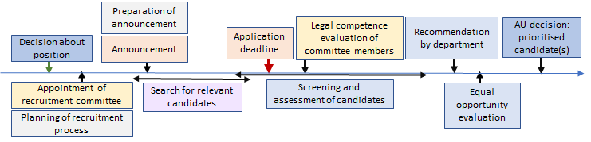Further is specified the various steps that should be included after a strategic decision has been taken regarding the specific position.
General preparation
- Make a timeline with important milestones for the whole recruitment process.
- Establish the recruitment committee and strive to include at least one woman. In particular, a woman should take part in the interview of women candidates.
Preparation of announcement
Be aware that you only can use the assessment criteria specified in the announcement and that you must use all the specified criteria when assessing the candidates. For a quick and smooth process when assessing the candidates, the following preparation is important:
- Be specific and clear about the assessment criteria, including such as academic and research background, practical experience etc and personal characteristics and separate clearly between what is required and what is wanted. You must plan how the different required and wanted qualifications/characteristics will be assessed. If you are not able to assess something, you should not be included in the announcement.
- Be 100% clear about formal requirements, e.g. which documents that are required and when the latest the PhD must be approved or the diploma be available.
- Evaluate any restrictions needed to meet Norwegian requirements for export control. See ”Retningslinjer for kontroll med kunnskapsoverføring»
- Specify relevant language requirements (Scandinavian language and/or English).
Search for relevant candidates
In many research areas, there is a limited number of potential candidates and to reduce the risk for having to re-announce the position, you should:
- Use your network to spot and encourage relevant candidates to apply for the position.
Prepare for assessment before the application deadline
All that is prepared before the application deadline, will reduce the assessment time.
- Start preparing the advisory committee report with such as members of advisory group and other roles and the evaluation criteria to be used (must be identical to those in the announcement) for the different stages of the assessment (see further below). Be sure to use the template for advisory committee reports.
- Start preparing the interview guide by applying an available template [lenke] and adding other questions that are specific for the positions and references to be able to also assess further research background and such as personal characteristics that are specified in the announcement.
Legal competence evaluation (habilitetsvurdering) of committee members
Each member of the committee has to evaluate their legal competence and confirm their competence regarding the actual candidates.
Assessment of the candidates by the advisory committee
Assessment may start before the application deadline and if some early candidates are highly qualified, interviews and reference checking for these should take place before the application deadline.
Often a huge number of documents may be attached to each application, and even if there are only a few applications, assessment time may be considerably reduced if the assessment is done by the following steps:
- Exclude all incomplete applications, i.e. where any of the required documents are not provided. (Then no time is needed to read all details.)
- If relevant, exclude candidates that do not comply with the guidelines for export control.
- Exclude all candidates with a non-relevant background (i.e. clearly not matching the announced required background).
- Assess the candidates based on their applications and attached documents against the announced assessment criteria (that can be assessed based on the documents) to select those who should be interviewed. If only one gender, e.g. male, is selected further, you should consider whether the best qualified female candidate might be qualified after gaining more information from the interview and references, and in case select her for interviews. The same applies to physically disabled applications and to immigrant applicants.
- Conduct the interviews with the selected candidates by using a prepared interview guide that contains a set of common questions to all candidates and in addition specific questions related to issues in their application documents. Evaluate whether some of the candidates are not qualified for the position based on the interview.
- Make the final scoring for each assessment criterion (all criteria in the announcement must be included) and the total scoring, which may be supported with a short narrative, to prioritise and rank candidates for the position. If there are few candidates and there are clear differences between them, a short narrative may be enough to give the rationales for the ranking.
Recommendation and further handling from the department
As soon as the assessment report from the advisory committee is provided, the department is responsible for the follow steps:
- Making final recommendation (innstillingen) by using the template based on the report from the advisory committee;
- Sending the documents to the Equal Opportunity Commissioner (likestillingsombudet) for evaluation;
- Sending the documents including the declaration from the Equal Opportunity Commissioner to the faculty for final decision by AU (Ansettelsesutvalget).

