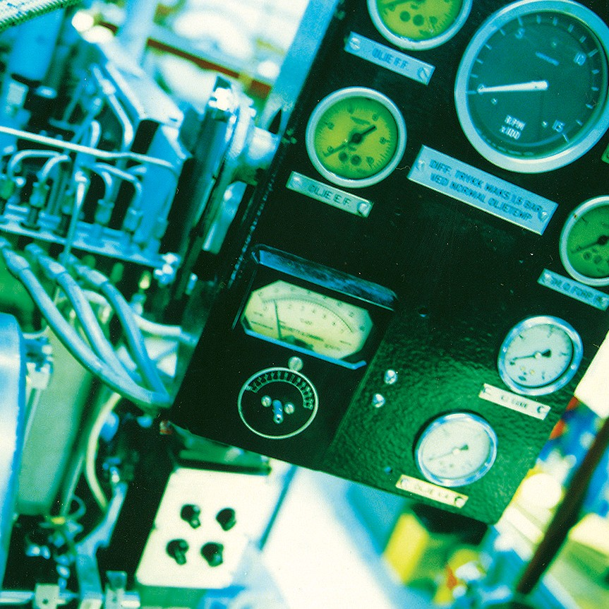
Place your preferred picture here.

And of course, delete this picture, box and textbox.

Author
Co-authors (optionally)

Title report. In some cases there are long titles.
Subtitle (optionally)

Place – date – year

Report
NTNU
Norwegian University of
Science and Technology
Faculty of xxxxxx xxxxxx
Xxxxxxxxx xxxxxxx
Department of xxxxxxxxxx
Xxxxxxxxx xxxxxxx

DATE
xx.xx.20xx

PROJECT NUMBER
xxxxxxxxxxxxxxxxx

NUMBER OF PAGES AND ATTACHMENTS
xxxxxxxx xxxxxxxxx xxxxx

CLASSIFICATION THIS PAGE
xxxxxxxxxxxxxx

CLASSIFICATION
xxxxxxxxxxxxxx

ISBN
xxxxxxxxxx

ABSTRACT

Title abstract
Xxxxxx xxxxxxxx xxxxxxxx
SIGNATURE

SIGNATURE

SIGNATURE

CORRESPONDING AUTHOR
xxxxxxxxxxxxxx

CONTROLLED BY
xxxxxxxxxxxxxx

APPROVED BY
xxxxxxxxxxxxxxx

REPORT NUMBER
xxxxxxxxxx

VERSION
Xxxx version number xxxx

AUTHOR
Co-authors (optionally)

CLIENT(S)
xxxxx xxxxxx xxxxxx xxxxxxxx

CLIENTS REF.
xxxxx xxxxxx xxxxxx xxxxxxxx

Report

Title report
Subtitle (optionally)
VERSION
xxxxxxxxxxxx

Background
DATE
xx.xx.20xx

VERSION DESCRIPTION
xxxxxxxxxxxxxx

Contents
Overskrift 1(Title 1) 5
Overskrift 2 (Title 2) 5
Overskrift 3 (Title 3) 5

Here the report begins

Overskrift 1(Title 1)

Use the quick styles, select the header and select Overskrift 1, 2 and 3 to get automatic table of contents.

You must update the table of contents as you make changes.

To update the table of contents, go to "References" and press "Update Table".

Then select "Refresh entire table" and press "OK", or right-click on the table of contents and select update field.

The rest of the text should have the formatting "Brødtekst rapport".

Overskrift 2 (Title 2)
Brødtekst (Body text)

Overskrift 3 (Title 3)
Brødtekst (Body text)

Lorem ipsum

