Phase 1 – Preparation for the Work Environment Survey 2021

The units name:
Name of leader and safety representative:
Date:

In order to achieve NTNU’s goals, we must work continuously with the development of a psychosocial and organizational work environment. In this work, the work environment survey is an important tool. In order to prepare a new survey, it is useful to reflect on experiences from previous work environment work at the unit, elements that have affected the work environment since the last survey, and objectives for further work environment development. The discussion guide is intended as an aid when preparing for a general meeting and presentation of a new survey.

The form must be filled in by the manager in collaboration with the safety representative and any other relevant key persons (e.g., Management support / coordinator for the Working Environment Survey at the faculty / area).

The form is completed and archived in ePhorte on the unit’s case file by 15 October 2021.
NB! A case file is created for each unit so that you can get the results of the survey at the same case: «Work Environment Survey 2021 UNIT ABBREVATION». A list of the unit abbreviations used in the survey will be available at The website for the survey from October.
If you have any questions, consult with the coordinator for the Work Environment Survey for your faculty/area in the joint administration.

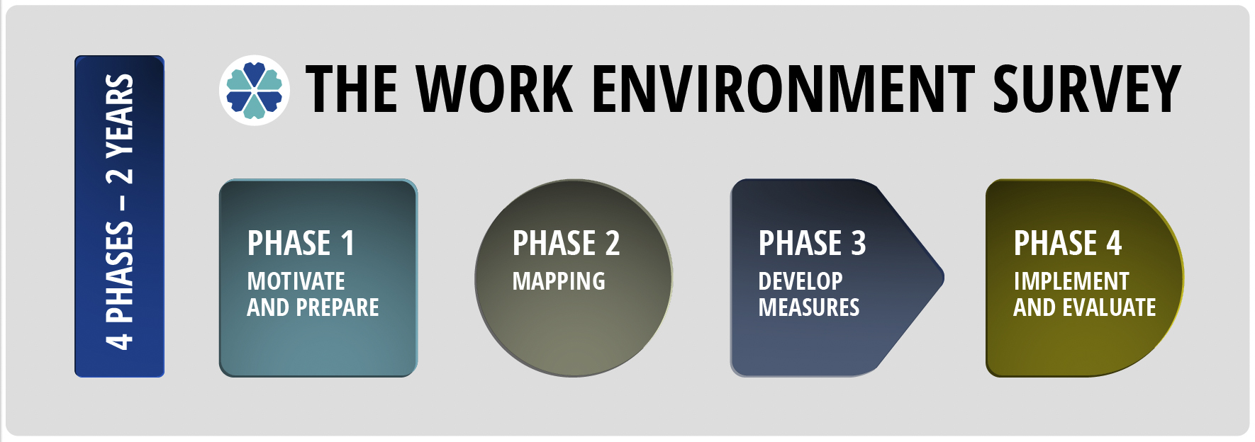

Questions for preparation:

- What do we want to achieve with the work environment work at our unit? (For example: A work environment that; contributes to us achieving our strategic goals, contributes to us becoming a leading professional environment, is experienced inclusively for everyone, contributes to us getting more and better research, contributes to better professional collaboration around xx courses for students in cohort II?).

- How can we make the best use of our previous experiences? Think about how you have worked in the various «phases» of the Work Environment Survey.

- Follow-up of action plans from the previous survey:
  - Which measures worked well? Why?
  - Which measures did not work as well? Why?

- Which aspects have affected the working environment since last time (pandemic, new management, structural changes, large turnover, conflicts)? Names, job titles and other things that can identify individuals are omitted

- Work environment development and measures must support our primary activities, research and teaching, and must therefore always be seen in connection with this. How can we use the Work Environment Survey, and the work environment work we do, into other ongoing processes?

