Recording exposure of student groups in connection with laboratory courses

- Create a user for the lab course in the substance index, Eco Archive. See separate instructions below. Provides user access to all necessary locations, i.e. all rooms necessary to attend the lab course.
  - Administrator access is required to create users.
- Create a case number in ePhorte for the applicable lab course. A new case number must be created for each edition of the lab course.
After creating the user, it is possible to record exposure at the lab course:
  - Log the user in to the lab course.
  - Select "Administration", "Exposure" and "Create new exposure".
  - Select the lab course as "Exposed person".
  - Add the ePhorte case number under "Comments".

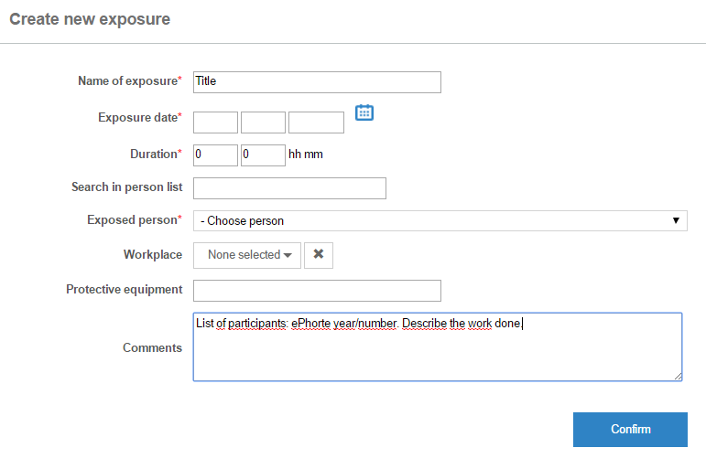

- From FS, retrieve the list of students participating in the lab course in year/semester X. The list must contain the students’ names and personal identification numbers.
  - The student advisers can help retrieving the list from FS. List of faculty student advisers: https://innsida.ntnu.no/web/guest/wiki/-/wiki/English/Student+guidance
- The list is archived as a journal entry under the appropriate case number in ePhorte
  - The journal entry containing the list should be given access code U: The Freedom of Information Act §13 and the Public Administration Act §13 – Confidentiality
For information:
- When a list is stored in ePhorte: The required storage time is fulfilled (up to 60 years) (cf. archive adviser and legal adviser).
- People who are registered for the lab courses are granted access to their own information upon request.
  - Such requests are made to the HSE Division (Arve Johansen or Ann Kristin Sjaastad)

Instructions for administrators for creating lab course users:
- Click "Administration" and "Users":
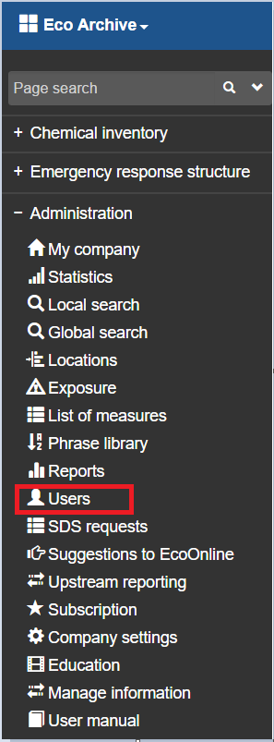

- Click "Create new user":
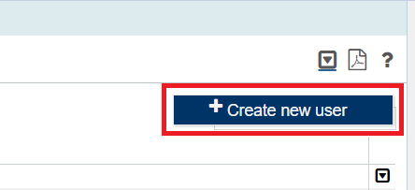

- Uncheck "Personal user" and check "Multiuser".
- Insert the applicable course code as "Name" and "User name".
- Add a password. Avoid very simple passwords, like "password" etc. Only the administrator creating the user for the lab course should know the user name and password.
- Select "Read" as the "Type of licence". Check any applicable locations for the course under "Choose location(s)".
- Click "Save".
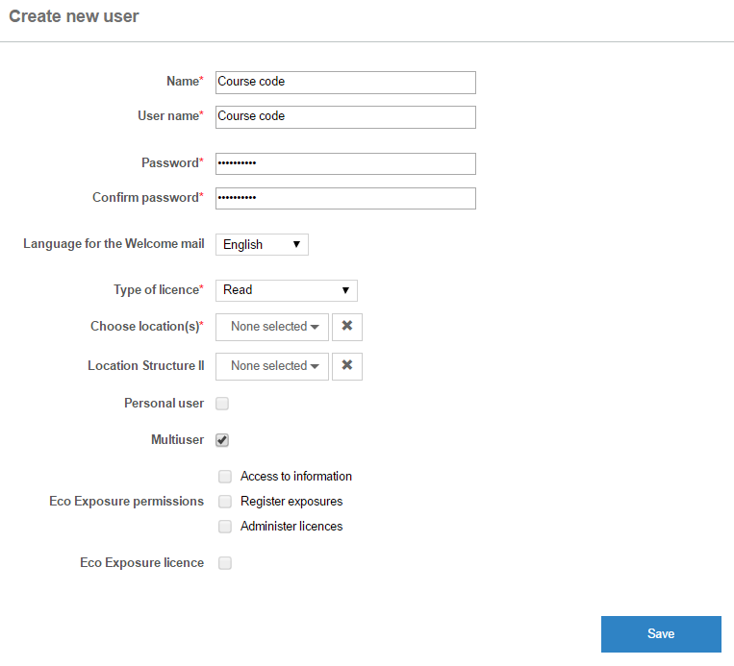

- Uncheck "Multiuser" and check "Personal user".
- Add a fictional e-mail address under "E-mail".
- Check "Eco Exposure licence".
- Add the course code in the "Personal ID number" field and click "Confirm personal ID number". Letters are okay, and there is no requirement for 11 characters.
- Add the applicable "faculty", "institute" or subject group under "Workplace".
- Click "Save".

The same Eco Exposure-user can be used for future editions of the same course. Multiple exposures can be recorded for the same user.

